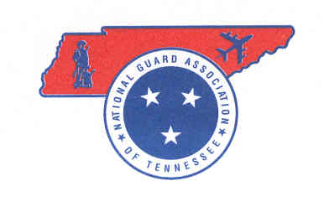
NATIONAL GUARD ASSOCIATION
OF TENNESSEE

4332 Kenilwood Drive
Nashville, Tennessee 37204-4401
Phone: (615) 833-9100
Fax: (615) 833-9173

www.ngatn.org

Enclosure #3

NGATN DRESS GUIDELINES

FORMAL or BLACK TIE
• Women: Military- Mess Dress or Service Uniform. Civilian- Wear a floor-length gown, a knee-length cocktail dress, little black dress or a dressy suit with heels.
• Men: Military- Mess Dress or Service Uniform. Civilian- Wear a dark suit and tie with dressy leather shoes Or wear a tuxedo, a black bow tie, a black cummerbund or vest, and black patent-leather shoes.

SEMI-FORMAL
• Women: Military- Service Uniform. Civilian- Wear a knee-length cocktail dress, a little black dress, a dressy skirt and top or even slacks with a dressy blouse.
• Men: Military- Service Uniform. Civilian- Wear a suit and tie in either a dark or light color, depending on the season and the time of day. Dress pants with a collared shirt and jacket. Add dressy leather shoes.

BUSINESS CASUAL
• Women: Military- Class B’s. Civilian- Wear dress pants, a casual dress, or a skirt with a nice blouse.
• Men: Military- Class B’s. Civilian- Wear khakis or dress pants with a collared shirt and loafers (or loafer-style shoes). You can also add a sport coat or blazer.

CASUAL
• Women: Wear a sundress, a skirt or pants with a pretty top.
• Men: Wear khakis/casual pants with a button-down, a sweater, or a polo shirt. Dress shorts or nice jeans are appropriate.

