NATIONAL GUARD ASSOCIATION OF TENNESSEE
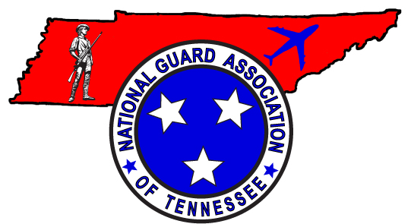
4332 Kenilwood Drive
Nashville, Tennessee 37204
Phone: 615-833-9100
Fax: 615-833-9173
www.ngatn.org

6 May 2022

144th (2022) NGAUS GENERAL CONFERENCE ANNOUNCEMENT

You are invited to attend the 144th National Guard Association of the United States (NGAUS) General Conference in Columbus, OH starting on 26 August and running thru 29 August 2022! Conference activities will be held at the Greater Columbus Convention Center.

For the Tennessee attendees, the conference activities will begin at 5pm on Friday, 26 August with registration packet pick-up at the Tennessee Caucus Meeting at the Sonesta Columbus Downtown hotel (meeting room TBD). The last official activity will be the States Dinner on Monday Night, August 29.

CONFERENCE HIGHLIGHTS:
Friday, 26 August-
NGAUS Golf Tournament- Bent Tree Golf Course
Joint Resolutions Committee
Tennessee Caucus Meeting- 5pm at Sonesta
Company Grade/Warrant Officer Mixer (Huntington Ball Park)
Senior Warrant Officer Mixer (Huntington Ball Park)
Field Grade Reception (Huntington Ball Park)
Saturday, 27 August-
Officer Professional Development
Army/Air Resolutions Committee
Area III Caucus
Exhibit Hall Ribbon Cutting
Opening Ceremony/Roll Call of States
Governors Reception (Center of Science and Industry)
Sunday, 28 August-
Second Business Session
Spouse Luncheon
Retired/Separated Caucus/Lunch
Warrant Officer Caucus/Lunch
OPD- 2nd Session
Task Force Meetings
Hospitality Night (Multiple Locations)
Monday, 29 August-
Air/Army Separate Sessions
Third Business Session
OPD- 3rd Session
States Dinner

HOTEL: The Tennessee delegation will be staying at the beautiful Sonesta Columbus Downtown Hotel. The hotel is located adjacent to the Convention Center. NGATN will reserve your room upon receipt of your Registration Form. Do not contact the hotel directly! Rooms will be reserved on a first come, first served basis. Room rate is $128 per night plus tax.

DELEGATES: Tennessee will be allocated approximately 45 Delegates. The NGATN Executive Council will determine Delegates from those Members who Register. Delegates registration fees will be paid by NGATN, but Delegates are responsible for all other costs to include hospitality room fees. Delegates are expected to attend the Business Sessions and Breakouts!

REGISTRATION PROCESS:
- Go to www.ngatn.org and print off a copy of the Registration Form or print the attached copy.
- Submit your Registration Form NLT 1 July 2022 to the NGATN Conference Coordinator, JJ Clemons at jj@ngatn.org or call the office at (615) 833-9100.
- A Room Deposit of $100.00 per room is required, along with the Registration Form. This deposit will be applied to your final statement for hotel accommodations. NGAUS will not refund advance room deposits on cancellations received after 3 August 2022. The hotel will honor the reduced rate for two (2) days prior to the Conference and two (2) days after the Conference. A credit card is REQUIRED for Reservation Guarantee. (NOTE: Credit Card Expiration Date must be no earlier than September 2021.)
- The Registration Fee of $180.00 covers admission to the General Conference, Exhibit Hall, Governors Reception, Hospitality Night, Spouse Luncheon, States Dinner and other selected Conference activities. Events that require additional payment include Golf, Fun Run, and Retiree Luncheon. If you are selected to be a Delegate your Registration Fee will be returned!
- Everyone pays the $25 Hospitality Room fee.
- Checks should be made payable to NGATN.
- After submitting your Registration Form you will receive additional conference information. Information will include the Conference Registration confirmation, Delegate List, Conference Agenda, Dress Guidelines, Committee/Task Force assignments and more detailed information about the Conference and the city of Columbus. All Cancellations are subject to a $15.00 Cancellation Fee.

Everyone is encouraged to visit our website at www.ngatn.org or NGAUS website at www.ngaus.org for more information. Check out the 144th NGAUS Conference page for hotel information, the preliminary agenda and all the exciting events scheduled for you and your spouse/guest. Make your plans now to attend and be part of this year’s conference! See you in Columbus!!

Call the NGATN office at (615) 833-9100 if you have any questions!!

Sincerely,

LTC Travis McKnight
President

