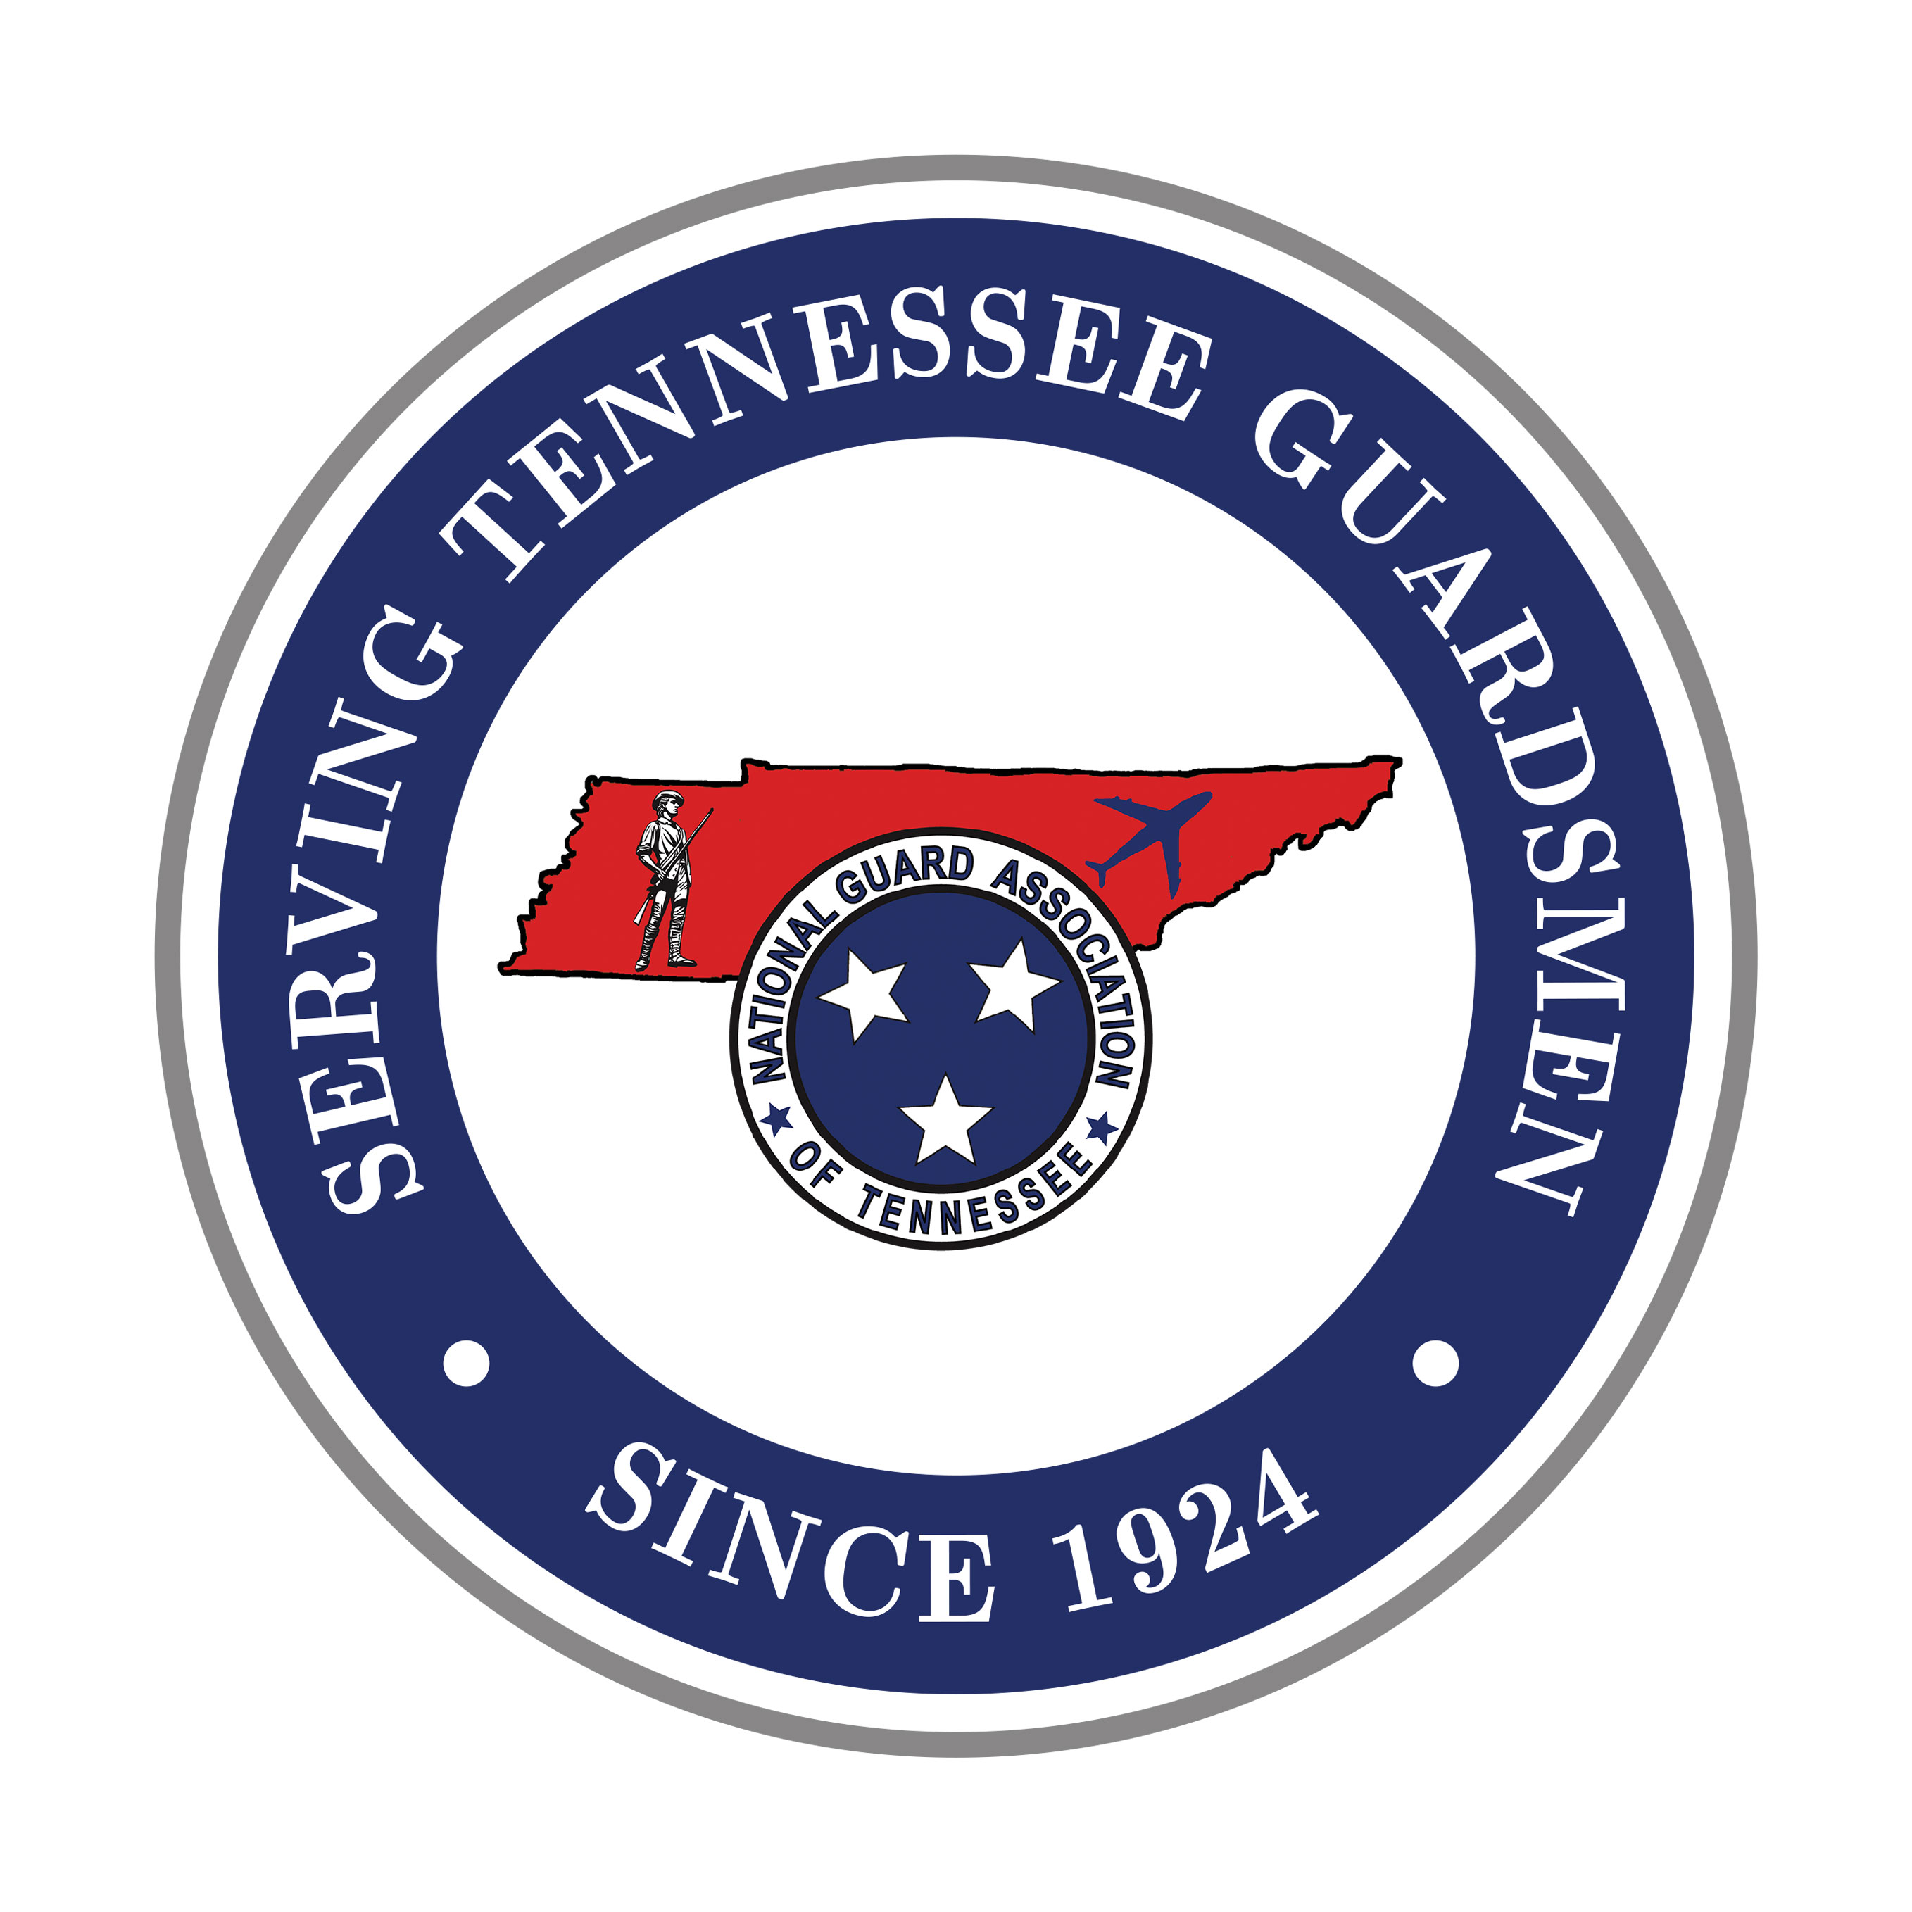NATIONAL GUARD ASSOCIATION

OF TENNESSEE

**4332 Kenilwood Drive**

**Nashville, Tennessee 37204-4401**

**Phone: (615) 833-9100**

**Fax: (615) 833-9173**

**www.ngatn.org**

***CORPORATE AGENDA***

***2026 NGATN GENERAL CONFERENCE***

***12-14 February 2026***

**THURSDAY, 12 February**

**10am-1pm Golf Event –** TopGolf, Nashville

**6pm-9:30pm Corporate Partner Reception -** Platinum Plus, Platinum, Gold, and Silver Levels

**(**Dress- Business Casual)

**FRIDAY, 13 February**

**8:45 am Ribbon Cutting Ceremony**

**\*9am-11am Exhibits Set-Up**

**\*11am-6pm Corporate Exhibits Open**

**6pm-11:45pm Hospitality Night (4 Army Brigades and 3 Air Wings)**

**(**Dress-Casual)

**SATURDAY, 14 February**

**\*7am-2pm Corporate Exhibits Open**

**8am Business Session** – LTC Meredith Richardson, President

**9:45-10:45am Coffee Break & Visit Exhibits**

**10:45am Business Session** – LTC Meredith Richardson, President

**1230 Recess**

**\*2pm-3pm Corporate Exhibit Tear-Down**

**5:30pm Social (Cash Bar)**

**6:30pm Doors Open for Banquet**

Dress- Formal (Suit and Tie, Nice Dress or Pants Suit))

**6:45pm Dinner**

**7:30pm Presidents Time and Entertainment**

**8:45pm Adjournment and Retire the Colors**

**9pm-11:45pm Hospitality Rooms Open and DJ!**

**SUNDAY, 15 February**

**Depart for Home - Safely!**

**\*\* Apart from the TopGolf Event, all events are held at the Embassy Suites Conference Center (Murfreesboro, TN)**