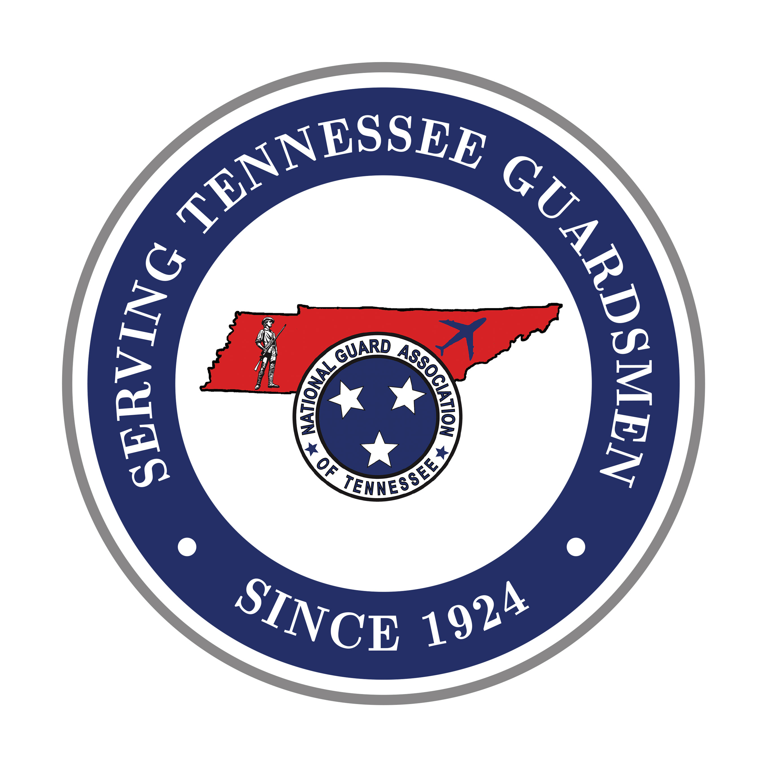
NATIONAL GUARD ASSOCIATION
OF TENNESSEE

4332 Kenilwood Drive
Nashville, Tennessee 37204-4401
Phone: (615) 833-9100
Fax: (615) 833-9173

www.ngatn.org

CORPORATE AGENDA
2027 NGATN GENERAL CONFERENCE
18-20 February 2027

THURSDAY, 18 February
10am-2pm Golf Event – TopGolf, Nashville (Lunch provided)
6pm-9:30pm Corporate Partner Reception - Platinum Plus, Platinum, Gold, and Silver Levels
(Dress- Business Casual)

FRIDAY, 19 February
8:45 am Ribbon Cutting Ceremony
*9am-11am Exhibits Set-Up
*11am-6pm Corporate Exhibits Open
6pm-11:45pm Hospitality Night (4 Army Brigades and 3 Air Wings)
(Dress- Casual)

SATURDAY, 20 February
*7am-2pm Corporate Exhibits Open
8am Business Session – Lt Col Matt McKeen, President
9:45-10:45am Coffee Break & Visit Exhibits
10:45am Business Session – Lt Col Matt McKeen, President
1230 Recess
*2pm-3pm Corporate Exhibit Tear-Down
5:30pm Social (Cash Bar)
6:30pm Doors Open for Banquet
Dress- Formal (Suit and Tie, Nice Dress or Pants Suit)
6:45pm Dinner
7:30pm Presidents Time and Entertainment
8:45pm Adjournment and Retire the Colors
9pm-11:45pm Hospitality Rooms Open and DJ!

SUNDAY, 15 February
Depart for Home - Safely!

** Apart from the TopGolf Event, all events are held at the Embassy Suites Conference Center (Murfreesboro, TN)

